Mono brewer detail design

DOC. No.: | REV.: 00 |  |  | PRODUCT:
TITLE: Boiler detail design |  |  |  | Project:
Prepared by: | Peter Yang |  |  | Date:
Remark: | Approval:
Remark: |  | Department | Title |  |  | Signature
Remark: | 1 | Electronic R&D
Remark: | 2
Remark: | 3
Remark: | 4

Revision | Description of Change | Author | Date
00 | Complete the mono brewer detail design document | Peter Yang | 2010.8.5

1. Mono brewer overview 4
2. The principles indicate of Mono brewer 4
2.1. The mechanical of mono brewer: 4
2.2. The sensors and magnets principle about the cylinder control : 5
3. Mono brewer control 5
3.1. Mono brewer state 5
3.2. Mono brewer JOB flowchart 6
4. Mono brewer error code define 7
5. To be continue 8
5.1. Objective 8
5.2. Scope 8
5.3. Reference 8
5.4. Abbreviations 8
Appendix 9

Mono brewer overview
There are different kinds of brewer in the coffee machine. Such as esbrewer and mono brewer. Mono brewer function is brewing instant coffee and tea.
Mono brewer is a fresh brewing machine. Compared with the esbrewer, it demands a relatively low pressure.

The principles indicate of Mono brewer

The mechanical of mono brewer:
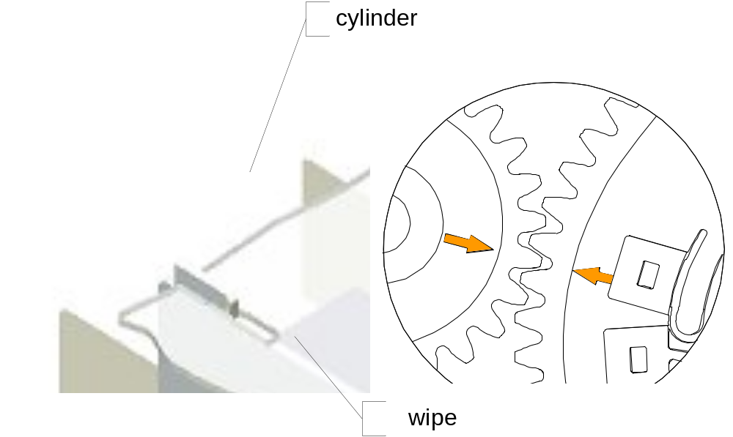
The mono brewer consists of two parts: cylinder and wipe. The cylinder control is the most complex moving parts. The following section introduces the cylinder software control.

The sensors and magnets principle about the cylinder control :
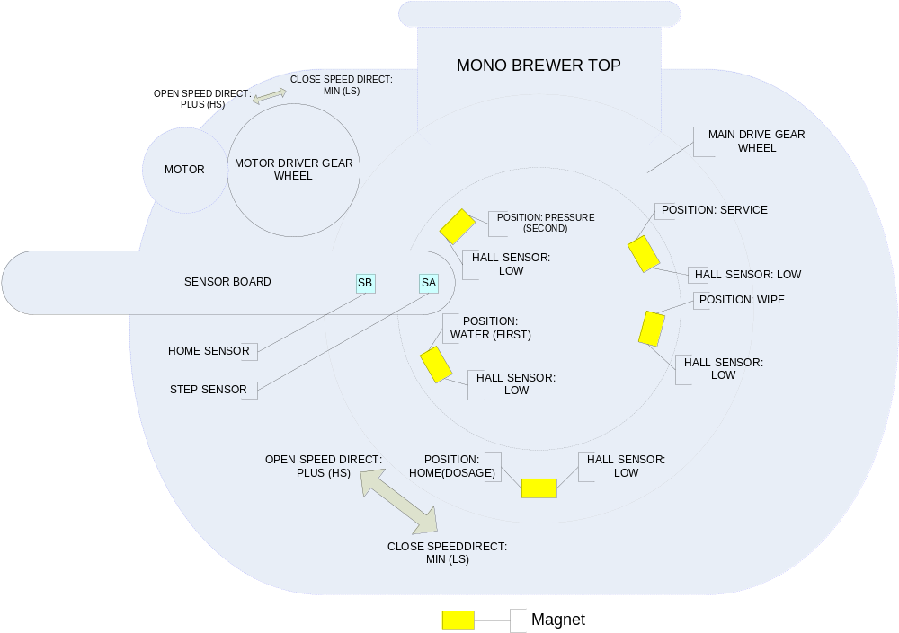

Mono brewer control

Mono brewer state
There are seven states in Mono brewer shows in the following.

UNDEF_STATE
DOSAGE_STATE
WATER_STATE
PRESSURE_STATE
SERVICE_STATE
ERROR_STATE

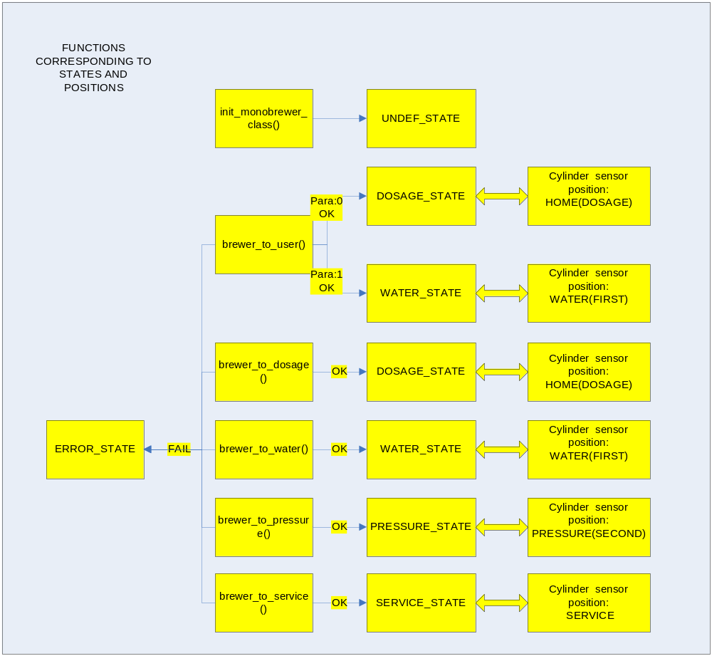

Mono brewer JOB flowchart
To make the state process more clear, here is the flow char of Mono brewer as follow.
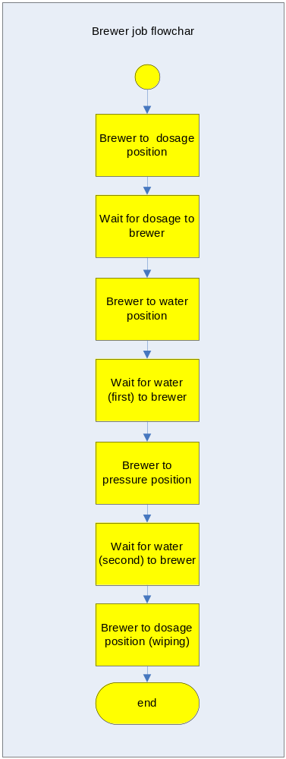

Mono brewer error code define
EVA error code | Event description | Definition | Is Fatal | Remarks
 | Mono brewer move fail | Mono brewer move fail(pid, timeout) | Yes | E_MONOBREWER_FAIL

To be continue

Objective

Scope

Reference

Abbreviations

Appendix

